Assignment 1: Personal Details Using Primitive Data Types
Objective: Practice variables and System.out.println.
Question:
Write a Java program that:
- Stores the following details using primitive data types only:
  - Age (int)
  - Height in centimeters (float)
  - Mobile number (long)
  - Is student (boolean)
- Prints all the values on separate lines.

OutPut=
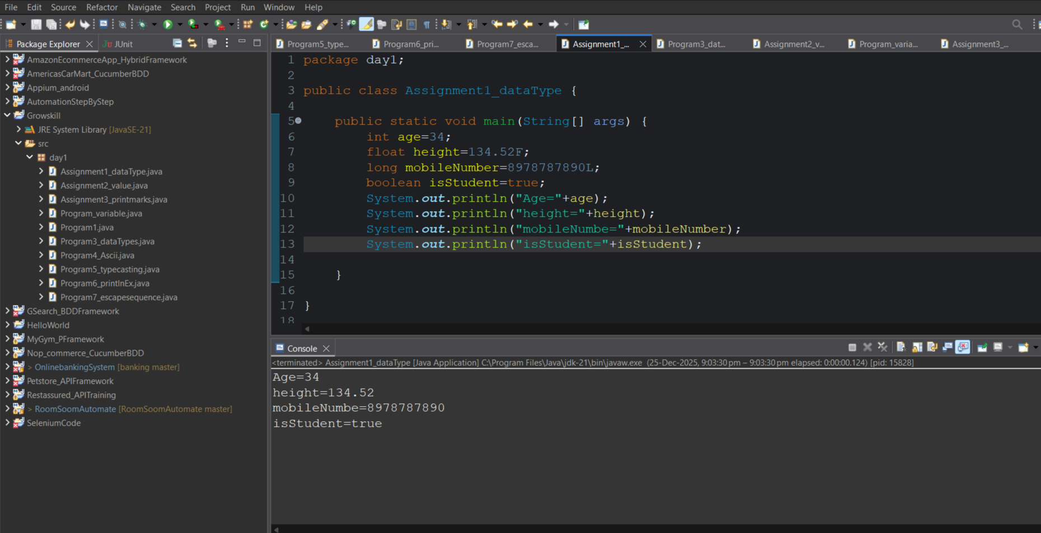

Assignment 2: Display All Primitive Data Types
Objective: Understand Java primitive data types.
Question:
Write a Java program that declares one variable for each primitive data type:
- byte
- short
- int
- long
- float
- double
- char
- boolean
Assign values and print them.

Output=
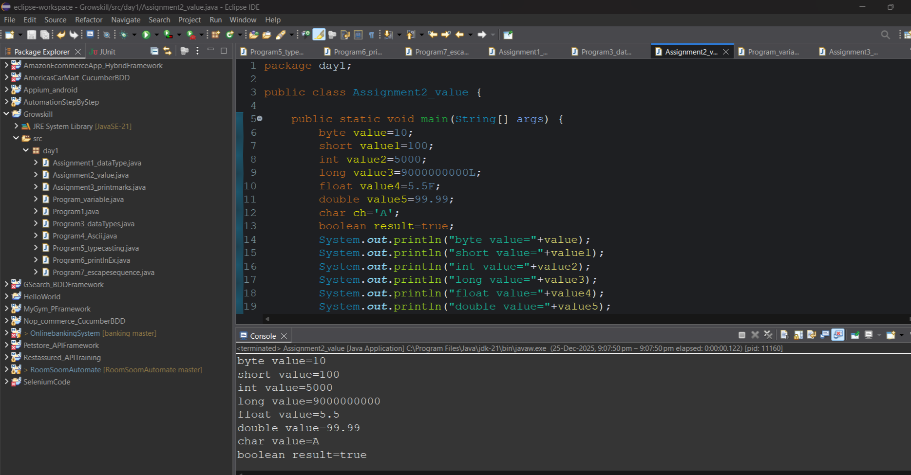

Assignment 3: Marks of Three Subjects
Objective: Practice using integer variables.
Question:
Write a Java program that:
- Stores marks of three subjects in int variables
- Stores pass/fail status in a boolean variable
- Prints all values on separate lines
Output=
